**SECTION 5**

# ER Diagram of Library Management System

[ER Diagram](https://www.geeksforgeeks.org/introduction-of-er-model/) is known as Entity-Relationship Diagram, it is used to analyze the structure of the Database. It shows relationships between entities and their attributes. An ER Model provides a means of communication.

The Library Management System database keeps track of readers with the following considerations:-

The system keeps track of the staff with a single-point authentication system comprising login ID and password.

Staff maintains the book catalog with its ISBN, Book title, price (in INR), category (novel, general, and story), edition, author Number, and details.

A publisher has publisher ID, the Year when the book was published, and the name of the book.

Readers are registered with their user ID, email, name (first name, last name), Phone no (multiple entries allowed), and communication address. The staff keeps track of readers.

Readers can return/reserve books that are stamped with the issue date and return date. If not returned within the prescribed period, it may have a due date too.

Staff also generate reports that have reader ID, registration no of the report, book no, and return/issue info.

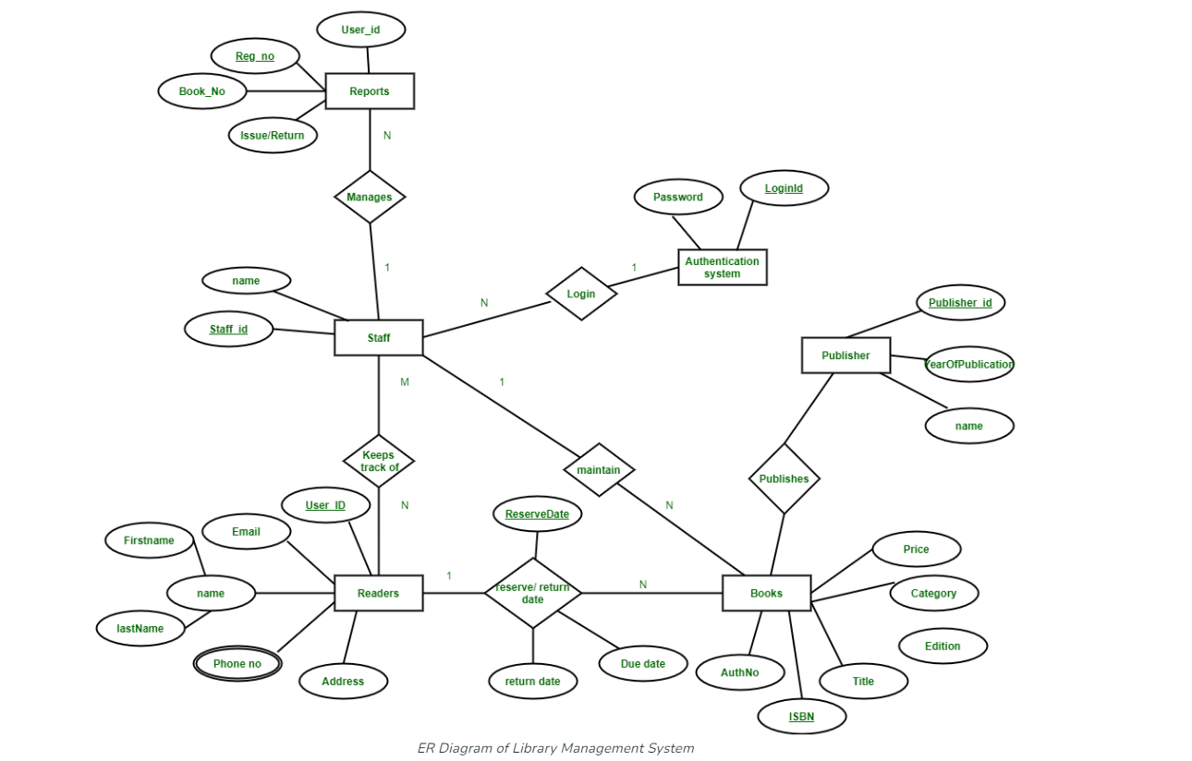

This Library ER diagram illustrates key information about the library, including entities such as staff, readers, books, publishers, reports, and authentication system. It allows for understanding the relationships between entities.

**Entities and their Attributes: –**

**Book Entity:**It has author, ISBN, title, edition, category, and price. ISBN is the Primary Key for the Book Entity.

**Reader Entity:**It has a User ID, Email, address, phone no, and name. Name is a composite attribute of first name and last name. Phone no is a multi-valued attribute. User ID is the Primary Key for the Reader entity.

**Publisher Entity:**It has the Publisher ID, Year of publication, and name. Publisher ID is the Primary Key.

**Authentication System Entity:**It has a Login ID and password with the Login ID as the Primary Key.

**Reports Entity:**It has User ID, Reg_NO, Book_NO, and Issue/Return date. Reg_NO is the Primary Key of the report entity.

**Staff Entity:**It has name and staff ID with staff ID as the Primary Key.

**Reserve/Return Relationship Set:**It has three attributes: Reserve date, due date, and Return date.

**[Relationships](https://www.geeksforgeeks.org/attributes-to-relationships-in-er-model/)between Entities: –**

A reader can reserve N books but one book can be reserved by only one reader. The relationship 1:N.

A publisher can publish many books but a book is published by only one publisher. The relationship 1:N.

The staff keeps track of readers. The relationship is M: N.

Staff maintains multiple reports. The relationship 1:N.

Staff maintains multiple Books. The relationship 1:N.

The authentication system provides login to multiple staff. The relation is 1:N.

There are three (3) levels of Entity Relation Diagram (ERD)

1. **Conceptual ERD (Entity-Relationship Diagram)**

The conceptual ERD represents the high-level view of the data model without going into too much detail regarding attributes or data types. It focuses on the entities and their relationships. In the context of a Library Management System, you would expect to see entities like Book, Author, Member, Library Staff, Loan, etc. Relationships between these entities would indicate how they are connected, for example, a Book may be written by one or more Authors, a Member can borrow one or more Books, etc. Attributes like Book ID, Author ID, Member ID, Title, Name, etc., may be included, but not in detail.

1. **Logical ERD:**

The logical ERD adds more detail to the conceptual ERD by specifying attributes for each entity. It provides a clear picture of the database's structure, including primary keys, foreign keys, and other constraints. In the Library Management System, the logical ERD would include details like Book ID, ISBN, Title, Author ID, Author Name, Member ID, Member Name, Loan Date, Return Date, etc., along with their respective data types and constraints.

1. **Physical ERD**

The physical ERD is even more detailed and includes implementation-specific details like indexes, table structures, data types supported by the database management system, etc. It's essentially a blueprint for the actual database implementation. In the Library Management System's physical ERD, you would see details like table names, column names, data types (e.g., VARCHAR, INTEGER), primary keys, foreign keys, indexes, etc.